**Week-8**

**Git-HOL**

**3. Git-HOL hands on**

**Branching:**

1. **Create a new branch “GitNewBranch”.**
2. **List all the local and remote branches available in the current trunk. Observe the “*” mark which denote the current pointing branch.**
3. **Switch to the newly created branch. Add some files to it with some contents.**
4. **Commit the changes to the branch.**
5. **Check the status with “git status” command.**

**Code:**

**Git bash:**

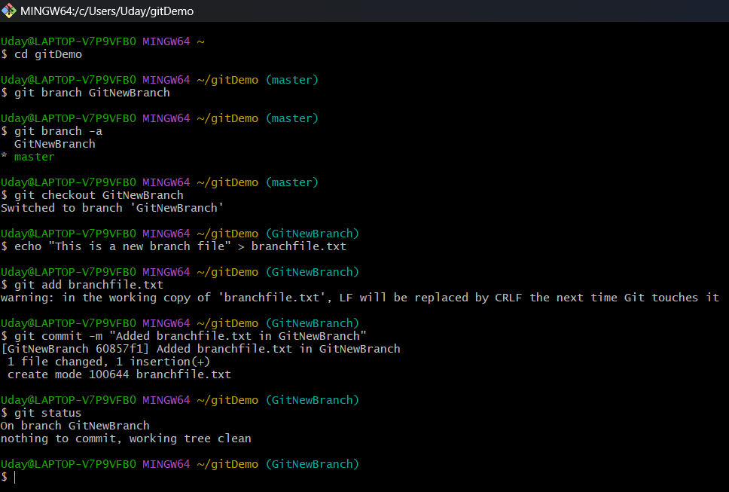

**Merging:**

1. **Switch to the master**
2. **List out all the differences between trunk and branch. These provide the differences in command line interface.**
3. **List out all the visual differences between master and branch using P4Merge tool.**
4. **Merge the source branch to the trunk.**
5. **Observe the logging after merging using “git log –oneline –graph –decorate”**
6. **Delete the branch after merging with the trunk and observe the git status.**

**Code:**

**Git bash:**

